THE NEW ENGLAND SCHOOL OF
BIOENERGETIC MEDICINE

Reconnect With The Rhythms of the Natural World


Catalog

Change Your Life … Change the World

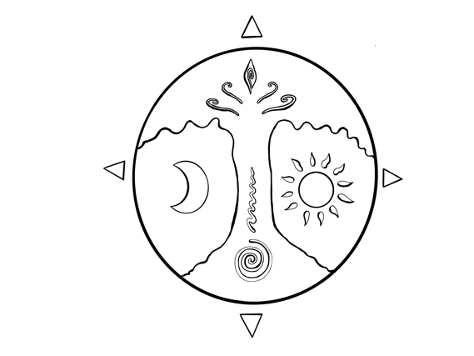

THE NEW ENGLAND SCHOOL OF BIOENERGETIC MEDICINE
  - CATALOG AND STUDENT HANDBOOK
School Address:
818 Main Rd, Stamford, VT 05352

Mailing Address:

P.O. Box 72
North Adams, MA 01247

(802) 304-2824

Email:info@newenglandschoolbem.org

www.newenglandschoolbem.org

The New England School of Medicine is a non-profit organization under section 501(c)(3).
The content of this Catalog and Student Handbook cannot be reprinted or reproduced without
written consent from the New England School of Bioenergetic Medicine.
Copyright @ 2025 New England
Copyright @ 2025 New England School of Bioenergetic Medicine and University of Northern California
All Rights Reserved. Registered 501(c)(3) EIN 68-0298406

A MESSAGE FROM THE EXECUTIVE DIRECTOR
The New England School of Bioenergetic Medicine welcomes you to a dynamic community where creativity, collaboration, and transformation thrive. Guided by a team of passionate and dedicated faculty and staff, NESBEM offers more than an education—it sparks discovery, nurtures growth, and creates pathways to endless opportunities.
At NESBEM, we view a road as a defined path, but a journey as an open invitation to discover, grow, and transform. Our mission is clear: to inspire and empower students like you to unlock your full potential and make a lasting impact on the world.
Here, future leaders are equipped with the tools, resources, and unwavering support needed to shape their destinies and drive meaningful change.
Collaborating with the Quantum Coherence Initiative reinforces our commitment to advancing innovative education and discovery. Our programs are thoughtfully designed to inspire personal growth, unlock human potential, and empower individuals to create change on both local and global levels. Whether taken as standalone experiences or integrated into a larger framework, our programs encourage students to embrace transformation and make a lasting impact.
But NESBEM is more than just a school—it’s a vibrant, holistic community devoted to personal development, ecological stewardship, and a shared mission to serve humanity, the planet, and all living beings. Whether you aim to deepen your expertise in integrative medicine or become a leader for change in your field, NESBEM offers a transformative journey rooted in balance, discovery, and coherence.
Throughout this catalog, you will find imagery of Stone Lions Farm, one of the cornerstones of our mission. This sanctuary is devoted to education and research that support the well-being of all life, serving as a space for physical, mental, and spiritual renewal. It is a place where connection, inspiration, and regeneration thrive.
Welcome to NESBEM—a place where learning meets purpose, and transformation is just the beginning. Together, let us explore new dimensions of discovery, balance, and coherence.

Warm Regards,

Stephanie Shelburne, Ph.D.

Executive Director, New England School of Bioenergetic Medicine

TABLE OF CONTENTS
A MESSAGE FROM THE EXECUTIVE DIRECTOR 6
TABLE OF CONTENTS 8
ABOUT THE NEW ENGLAND SCHOOL OF BIOENERGETIC MEDICINE 11
MISSION 11
TEACHING COMMUNITY 11
ARTICULATION AGREEMENT 12
STUDENT CATALOG AND HANDBOOK 12
GENERAL INFORMATION 13
ADMISSIONS AND ENROLLMENT 13
INSTRUCTIONAL DELIVERY 15
PROGRAM COMPOSITION 15
PROGRAM CANCELATION 16
STUDENT RIGHTS AND RESPONSIBILITIES 16
INTRODUCTION TO RESPONSIBILITIES 16
FAMILY EDUCATION RIGHTS AND PRIVACY ACT 17
DIRECTORY INFORMATION 17
PRIVACY POLICY 17
CONFIDENTIALITY AND ACCESS TO STUDENT RECORDS 18
TRANSCRIPTS 18
NAME, ADDRESS or EMAIL CHANGES 18
ACADEMIC GUIDELINES 18
ATTENDANCE 18
GRADING AND EVALUATION 19
COURSE COMPLETION 19
WITHDRAWAL 20
REFUNDS UPON WITHDRAWAL 20
RE-ENROLLMENT 21
PROGRAM COMPLETION 21
COMPUTER REQUIREMENTS 21
POLICIES AND PROCEDURES 23
ETHICAL STANDARDS 23
CONFLICT RESOLUTION 23
DIVERSITY 23
SUSTAINABILITY 24
DISCRIMINATION, HARASSMENT, AND SEXUAL HARASSMENT 24
SEXUAL HARASSMENT 24
DISCRIMINATORY HARASSMENT 25
ILLEGAL DRUGS AND ALCOHOL 25
TOBACCO AND ELECTRONIC CIGARETTES/VAPORIZERS 26
WEAPONS 26
POLICY VIOLATIONS 26
ROMANTIC RELATIONSHIPS BETWEEN EMPLOYEES AND STUDENTS 26
STUDENT GRIEVANCES 26
ACADEMIC INTEGRITY 27
RETENTION OF ORIGINAL WORKS 27
FREEDOM OF EXPRESSION 27
GENERAL ARTIFICIAL INTELLIGENCE 28
STUDENT GUIDELINES FOR ONLINE INTERACTION 28
BULLYING AND CYBERBULLYING 29
PHOTOGRAPHY AND VIDEO RECORDING 30
ACADEMIC PROGRAMS 32
APPLIED BIOENERGETIC MEDICINE 32
THERAPEUTIC BIOBODY INTEGRATION 38
FOUNDATIONS OF LIVING WELL: ANCIENT ROOTS, MODERN RESONANCE 43
NATURE-BASED THERAPEUTICS 45
INTEGRATIVE HERBAL MEDICINE 49
FOUNDATIONS OF MASSAGE THERAPY PROGRAM 54
CONTACT INFORMATION 57
CATALOG - ACKNOWLEDGEMENT 59

ABOUT THE NEW ENGLAND SCHOOL OF BIOENERGETIC MEDICINE

Guided by the visionary leadership of Dr. Stephanie Shelburne and inspired by the mission of UNC Founder Dr. Y. King Liu, our purpose is to empower individuals, practitioners, and leaders to achieve energetic alignment and unlock vitality and well-being in their lives and communities. As a 501(c)(3) non-profit organization, we are dedicated to advancing integrative science and health through our unique framework, the "Three Sisters of Science"—Curiosity, Calibration, and Coherence. This innovative approach fosters a deep connection to oneself, to nature, and to the world around us.

At the New England School of Bioenergetic Medicine, we are redefining wellness by integrating the wisdom of Eastern and Western medicine with cutting-edge scientific advancements. As part of the Quantum Coherence Initiative, we are dedicated to fostering a deeper understanding of health, energy, and balance through innovative education and exploration. Every aspect of our programming is carefully designed to nurture ecological awareness, inspire ethical reflection, and provide hands-on experiences that promote growth and discovery.

MISSION

The mission of the New England School of Bioenergetic Medicine is to provide a cohesive, practical, and professional framework that blends modern science with ancient wisdom. This framework encourages reconnection with the natural world's rhythms while teaching real-world applications for health and well-being for both humans and non-humans.

TEACHING COMMUNITY
The vibrant teaching community at the New England School of Bioenergetic Medicine, though small, is deeply passionate. It includes a diverse group of professionals such as Integrative Health Specialists, Researchers, Professors, Traditional Medicine Practitioners, Emergency and Public Health Officers, Environmentalists, Journalists, Leaders, and Activists, among others. We share a strong commitment to personalized, experiential learning, a love for the beauty of nature, and a dedicated focus on enhancing global health and wellness.

ARTICULATION AGREEMENT

The New England School of Bioenergetic Medicine and Saybrook University have formed an articulation agreement allowing NESBEM graduates to transfer credits to Saybrook University under specific guidelines. This agreement will facilitate credit transfer and degree completion for students; help prevent the duplication of courses within programs of study and support our students' educational growth and professional development.

STUDENT CATALOG
The catalog will guide you as an NESBEM student and help you maximize your experience with us. Inside, you will find essential information about our policies, procedures, and opportunities. While we strive to ensure the accuracy of all information provided, NESBEM reserves the right to update course offerings, tuition, and the academic calendar as necessary.

Effective communication is crucial to our commitment to your success. To stay informed, we encourage you to check your email and Mighty Networks regularly, as these are our primary channels for school communications. These platforms will keep you updated with important information, deadlines, and announcements. You are responsible for staying informed and acting based on the information provided.

Welcome to NESBEM—we are excited to be part of your journey!

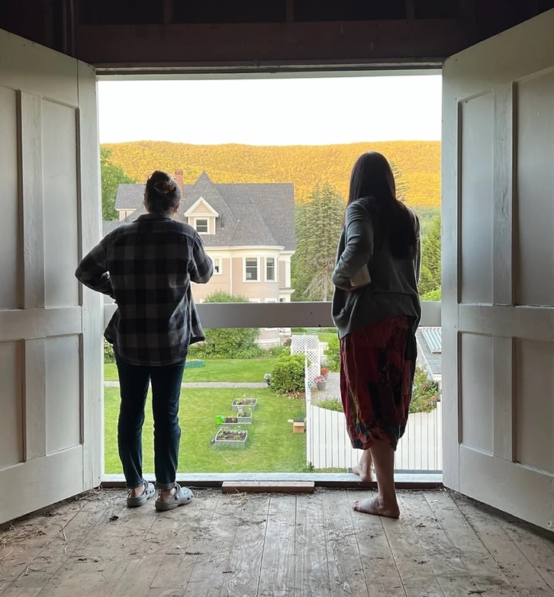

GENERAL INFORMATION

ADMISSIONS AND ENROLLMENT
The New England School of Bioenergetic Medicine (NESBM) has an open-door admissions policy, welcoming anyone interested in our programs, courses, or activities. We encourage applications from individuals of all backgrounds, regardless of race, color, national origin, religion, gender, age, or disability. At NESBM, we are committed to fostering a diverse and inclusive community of students.

We do not accept transfer credits or hours from other institutions, as our programs are designed to provide a unique and interconnected learning experience. Our flexible admissions process makes it easy for you to start your journey today.

We are pleased to offer our programs once or twice annually, welcoming students from throughout the United States and internationally without requiring residency. We look forward to supporting you as you begin your educational journey and advance toward your academic and professional goals. We invite you to join us and take this important step in your development.

ENROLLMENT PROCESS (10-month programs)
To enroll, please follow the steps and guidelines outlined below.
Step One: Fill out and submit the enrollment application, available online: https://www.newenglandschoolbem.org/admissions
Step Two: An Admission Representative will reach out to you via email within 48 hours of your submission. This email will contain general information about your program and will also provide you with an opportunity to ask any questions you may have. During this time, we will schedule a meeting with our Executive Director, Dr. Stephanie Shelburne. You can choose to have this meeting over the phone, via Zoom, or in person. This conversation will allow you to discuss how your chosen program aligns with your personal and professional goals. Additionally, it will offer valuable insights into your interest, commitment, and enthusiasm for our program, organization, and mission.
Step Three: After being accepted into the program, you will speak with the Academic Coordinator to review the available payment options and select the one that best fits your needs. A $100 registration fee is required at this time to confirm your place, and this fee will be applied toward your tuition.
Below is information regarding tuition and payment options.

PAYMENT OPTIONS
- Pay in Full: Make a single payment for the entire program and enjoy an exclusive 10% discount.
- Monthly Payments: Opt for our convenient monthly plan, spreading the cost over 10 months for added flexibility.
- Installment Plan: Alleviate your financial burden with an interest-free installment option, paying over 12 months.

PAYMENT OPTION | TUITION | MONTHLY PAYMENTS
PAYMENT OPTION | TUITION | 10 month | 12 month | 18 month | 24 month
Standard Tuition - $100 application fee | $5,900 | $590 | $491.66 | $327.77 | 245.83
Pay in Full – 10% discount | $5,310 | - | - | - | -
AABEM Student Member – 10% discount | $4,779 | $447.90 | $373.25 | $265.50 | $199.12
AABEM Full Member – 25% discount | $3,982.50 | $398.25 | $331.87 | $221.25 | $165.93
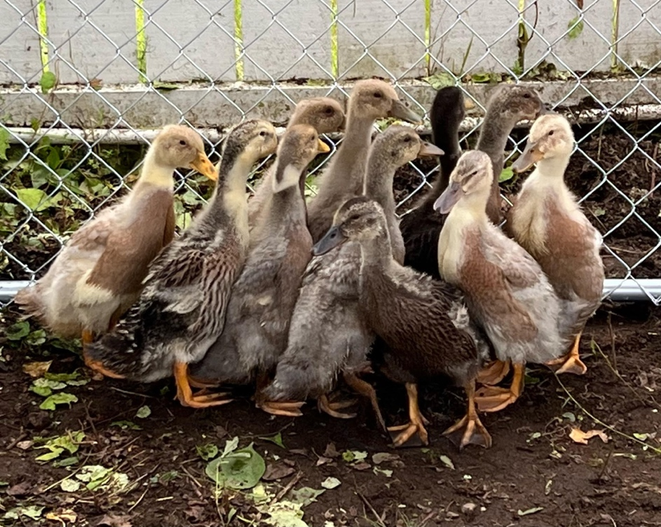

INSTRUCTIONAL DELIVERY
NESBEM provides an exceptional opportunity to access engaging online courses led by expert instructors, each with a proven track record in their respective fields. The flexible format enables students to tailor their learning experience to fit seamlessly into their busy lives, striking a perfect balance between personal and professional commitments. Each program is thoughtfully designed with clear instructional methods to deliver a thorough and enriching educational experience.

Online Learning Format: Our user-friendly Moodle platform enables students to fully engage in a vibrant virtual classroom assessing materials, instructions, and resources entirely online, eliminating the need to attend in-person classes.

Hybrid Format: Our hybrid format is designed to give you the best of both worlds. It combines the convenience of online learning with valuable hands-on experience through in-person or virtual equivalent sessions. This comprehensive approach ensures that you receive a well-rounded and engaging learning experience, making the most of your educational journey.

EXPERIENTIAL IN RESIDENCE LEARNING
Experiential in-residence learning involves actively participating in hands-on, real-world situations and then reflecting on those experiences, with a significant focus on integrating the learning within their lives and community.

We are actively working on this, and it will be available soon.

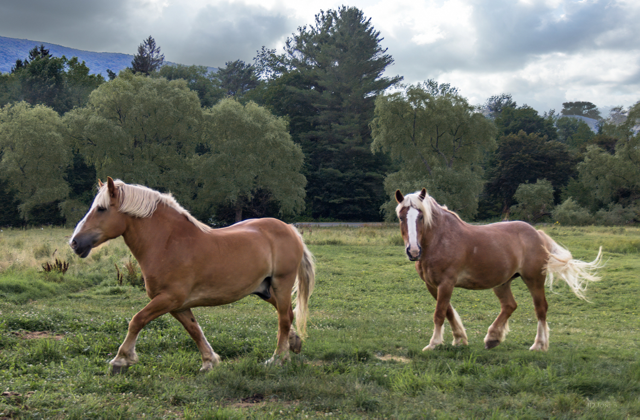

PROGRAM CANCELATION
In the event of cancellation due to low enrollment or instructor unavailability, we will promptly inform affected students via email or other communication methods. We recognize the importance of clear and timely updates and encourage students to remain informed about any changes. Those impacted by cancellations will have the opportunity to adjust their enrollment, ensuring their academic progress continues uninterrupted. Student success is our top priority, and we are committed to supporting students every step of the way.

STUDENT RIGHTS AND RESPONSIBILITIES

INTRODUCTION TO RESPONSIBILITIES
NESBEM encourages students to make choices that align with their personal development and emotional, social, and spiritual well-being.

By enrolling in or continuing at NESBEM, students agree to abide by the School's standards, which reflect its mission and values. Even if a student's personal beliefs differ, their decision to attend demonstrates a commitment to respecting and upholding these guidelines.

NESBEM reserves the right to take disciplinary action, including dismissal, against any student who disregards or violates its standards as outlined in the Catalog/Handbook. Students should review the most current version of this document, available on the NESBEM website, and familiarize themselves with its policies, rules, and procedures. Failing to do so or claiming ignorance of its contents will not excuse violations of school policies.

FAMILY EDUCATION RIGHTS AND PRIVACY ACT
NESBEM adheres to the Family Education Rights and Privacy Act of 1974, which aims to safeguard the privacy of education records. It establishes students' rights to inspect and review these records and outlines procedures for correcting inaccurate or misleading information through informal and formal hearings. Furthermore, students can file complaints with the Family Educational Rights and Privacy Act Office (FERPA) concerning any perceived non-compliance by the institution with the Act. For more information, please get in touch with the Administrative Office.

DIRECTORY INFORMATION
NESBEM will disclose the following items of directory information (as defined by the Family Educational Rights and Privacy Act) without obtaining written consent from the student: name, address, telephone number, program, dates of attendance, certificate awarded, enrollment and withdrawal verifications, and the most recent previous institution attended. Under the Family Educational Rights and Privacy Act, NESBEM has the authority to publish this information and routinely provide it to prospective employers, family members, other educational institutions, and others. Students are responsible for notifying the Administrative Office in writing if they do not wish for the above information to be released.

PRIVACY POLICY
We’re excited to welcome students to NESBEM and to provide you with the best services possible, we ask for some essential information. While there is no legal obligation to supply this data, the information requested is crucial for the college's processes and services. Refusing to provide the requested information may lead to denial of admission to a program, or other services.

The college assures students that their information will be protected from unauthorized disclosure.

CONFIDENTIALITY AND ACCESS TO STUDENT RECORDS
Our school maintains a secure digital record for every student, capturing key details like their name, address, date of birth, completed course work, grades, and contact hours. Access to these records is carefully controlled and is only available to faculty and professional staff for official school matters. Any release of records for external purposes will only occur with the student's consent or as legally required. Students are welcome to request a copy of their permanent records whenever necessary.

TRANSCRIPTS
Upon successful completion of the program, NESBEM will provide students with a Certificate of Completion and Transcripts.

NAME, ADDRESS or EMAIL CHANGES
Please contact the office directly to update your personal information, including your name, address, or email.

ACADEMIC GUIDELINES

ATTENDANCE
Student attendance is defined as active participation in course activities. Each course includes mechanisms for weekly engagement, documented through activities such as discussion posts, assignments, virtual classroom sessions, and chats. Consistent participation is crucial and is evaluated weekly, from Monday to Sunday, using Moodle as the tracking platform.

To receive attendance credit, students must log in, complete required activities, and actively contribute to discussions. This includes posting at least three times on the discussion board over three days, with the first post due by Wednesday. Simply logging in does not count as attendance; meaningful engagement is essential. Failure to complete assignments or participate in discussions will result in being marked absent for the week. Additionally, students are required to attend a four-day residential experience or complete equivalent coursework online.

In emergencies such as illness, accidents, or family bereavement, students must promptly contact their instructor and provide appropriate documentation to request extensions for late submissions. Students are also expected to regularly check their email, course announcements, and discussion forums to stay informed about updates and requirements. It is each student’s responsibility to maintain consistent communication and engagement. Failure to meet attendance expectation may lead to a recommendation for withdrawal from the course.

GRADING AND EVALUATION
NESBEM uses a pass/fail grading system, assessing students based on their active participation and successful completion of all assignments and activities. The evaluation criteria are as follows:

Attendance 10%
Participation 40%

Assignments 30%

Evaluation 20%
Clock hours will be completed by following a range of the guidelines listed below:

Reading Assignments | 12 -1 5 pages = one hour | 50 pages = 3.5 – 4 hours
Original Quality Discussions | 1 - 2 hours per question | 300–500-word response
Quality Response to Student Discussion(s) | One-half hour
Quiz / Test | One hour
Research Assignment | 2 – 3 hours | Includes write-up
Live Chat | 1 – 2 hours | .5 – 1 hour prep time per one hour of live chat
Writing Assignment | 1 -2 hours per page
Interview / Visit Assignment | 3 – 4 hours
Course Research Paper | 5 – 10 pages | 2 – 3 hours per week for  3 to 6 weeks
Daily Log in | 15 minutes

COURSE COMPLETION
At the conclusion of each module, students are asked to complete a course and instructor evaluation form. These evaluations are vital in assessing our programs and ensuring that the content remains relevant and impactful.

WITHDRAWAL
Students considering withdrawing from the program are strongly encouraged to contact the Executive Director. We recognize that every situation is unique, and the Executive Director will base her decisions on continuation or return on an individual basis. Withdrawal is officially acknowledged once the process begins.
If speaking directly with the Executive Director is not possible, students may submit a written statement via email outlining their reasons for this decision. The official withdrawal date is confirmed after students have either spoken with or emailed the Executive Director.
We understand that this is a significant decision, and our team is here to offer guidance and support throughout the process.


REFUNDS UPON WITHDRAWAL
Students withdrawing from the program may be eligible for a tuition refund, depending on the withdrawal date. The following factors determine the amount refunded after the first day of class:
- Tuition collected
- Enrollment date
- Weeks completed
- Total program duration
Our refund policy is as follows:
- 100% Refund: Students who withdraw before the first day of class, will receive a full tuition refund, minus the registration fee.
- 90% Refund: If up to 10% of the program is completed, 90% of the tuition will be refunded, minus the registration fee.
- 75% Refund: If up to 25% of the program is completed, 75% of the tuition will be refunded, minus the registration fee.
- 50% Refund: If up to 50% of the program is completed, 50% of the tuition will be refunded, minus the registration fee.
- No Refunds: There are no refunds if more than 50% of the program is completed.

RE-ENROLLMENT
Students seeking reenrollment are encouraged to contact Dr. Stephanie Shelburne, Executive Director. Each case will be carefully reviewed and given individualized attention.

PROGRAM COMPLETION
To complete our 10-month program, students must fulfill all required module hours, actively participate in residential experiences (or the equivalent), and complete all assigned coursework.

Upon program requirements met, students are awarded a Certificate of Completion. This personalized certificate, officially registered with NESBEM, will be mailed directly to the student’s address.

COMPUTER REQUIREMENTS
Verify that you meet the minimum technology requirements for participating in online or hybrid programs at the New England School of Bioenergetic Medicine.

Basic Computer Skills
- Sending/receiving emails and attachments
- Using a web browser and search engines
- Downloading and installing software
- Familiarity with browser plug-ins (e.g., PDF reader, video, audio)
- Using word processing, presentation software, and other productivity applications
- Experience/familiarity with various file formats such as .pdf, .rtf, .doc or .docx, and .txt
- Self-directed learning of new technology skills

Required Hardware
- A computer (desktop/laptop) or mobile device (smartphone/tablet) that is less than 5 years old
- Speakers/headphones/earbuds for listening to audio or videos presented in courses

Optional Hardware
- Webcam for course activities requiring video feedback, video test proctoring, or third-party tools

Required Software
- Internet Browser (i.e., Mozilla Firefox, Google Chrome, or Microsoft Edge preferred)
- Adobe Acrobat Reader or other PDF readers
Students with questions or concerns about coursework, should contact their instructor. Instructor office hours are found in the course materials on Moodle. Don't hesitate to ask for help—our instructors are eager to assist you on your learning journey.

If technical issues with Moodle arise, students should contact Moodle Customer Service at Moodle or call (866) 361-8965.

POLICIES AND PROCEDURES

ETHICAL STANDARDS
At NESBEM, we stand out with our distinct and ethical approach that influences everything we do. Our values of mutual respect, inclusivity, and a profound connection to the natural world energize us to act with integrity. We wholeheartedly encourage our students to embrace this mindful philosophy throughout their educational journey, empowering them to become thoughtful leaders.

We are passionate about fostering open communication, grounded in Living Systems Theory, which highlights the transformative power of dialogue in building meaningful relationships—among individuals, within communities, and across the entire biosphere. Our dedication to compassionate communication, along with unwavering integrity, forms the foundation of our interactions. By actively listening, embracing shared responsibility, and nurturing collaborative leadership, we create an environment where trust and cooperation flourish.

Our educators are dedicated to nurturing a supportive and collaborative learning atmosphere where everyone feels valued, empowered, and inspired to grow. We believe in the potential of every individual support each student's journey toward their highest self.

CONFLICT RESOLUTION
Disagreements are a normal and essential aspect of human interaction, enriching our relationships. While conflicts can feel intimidating, they present wonderful opportunities for personal growth and deeper connections. Facing these challenges may be tough, but with the right strategies, we can encourage constructive conversations and achieve positive outcomes. If you’re facing any interpersonal hurdles or unresolved issues with a student, instructor, or staff member, please don’t hesitate to connect with Dr. Stephanie Shelburne, Executive Director. She’s eager to support you in finding solutions.

DIVERSITY
NESBEM is dedicated to embracing and promoting diversity in all aspects of our work. Our committed to fostering an inclusive environment reflects our community, educational practices, and supportive policies. We aim to create a welcoming space where everyone feels valued and empowered. This drives our ongoing efforts and inspires us to continually improve and grow together.

SUSTAINABILITY
At the New England School of Bioenergetic Medicine, our passion for sustainability drives us to create a healthier planet for everyone! We wholeheartedly believe in the power of recognizing our impact and recognizing the significant connections between people and ecosystems. Together, we aspire to build a future that is equitable, vibrant, and resilient.

We're excited to make significant progress toward this vision by:
- Fostering a vibrant culture of sustainability through inspiring leadership and enthusiastic participation.
- Innovating impactful solutions by collaborating across disciplines, emphasizing the importance of education and research.
- Committing to environmental stewardship in every aspect of our operations, making a positive difference for all.

With these initiatives, we aim to nurture a harmonious relationship among individuals, communities, and the environment—both locally and globally.

DISCRIMINATION, HARASSMENT, AND SEXUAL HARASSMENT
NESBEM cultivates a vibrant and inclusive community, welcoming individuals of all ages, genders, races, ethnicities, nationalities, abilities, and veteran statuses. We ensure everyone with dignity, respect, and equality, celebrating our diverse strengths together.

SEXUAL HARASSMENT
At the New England School of Bioenergetic Medicine, we are fully committed to promoting a community built on professionalism and integrity. We believe in the responsible use of authority in every interaction, ensuring that everyone feels respected and valued. Our unwavering zero-tolerance policy against sexual harassment and misconduct reflects our dedication to creating a safe and nurturing environment for all students, faculty, and staff.

Sexual harassment, which includes any unwelcome sexual advances or inappropriate behaviors—whether verbal, physical, or otherwise—can create a toxic atmosphere that disrupts academic and professional growth. It is our collective responsibility to foster a culture of respect where every member feels empowered to thrive and contribute.

Harassment can take many forms, from verbal comments to physical actions or written communications. Even if certain behaviors may not align with strict legal definitions, we prioritize the well-being of our community and will address them as harassment when necessary.

Stalking is a particularly concerning form of harassment that involves the intentional and repeated following or threatening of an individual. This behavior can instill reasonable fear, intimidation, or distress in the targeted person and their loved ones, causing them significant anxiety and concern.

Moreover, sexual misconduct, which includes any non-consensual acts—such as unwanted touching or forced sexual encounters—is taken very seriously. We also recognize that dating violence, defined as violent conduct within romantic relationships, is part of this issue. We differentiate these actions from the normal social interactions expected in professional and academic settings.

By upholding these principles, we each play a vital role in cultivating a respectful, supportive, and thriving community at our school.

DISCRIMINATORY HARASSMENT
Harassment takes many forms, and it’s essential to recognize and address these harmful behaviors. This includes derogatory language, slurs, and the spread of damaging stereotypes, as well as intimidation based on race, gender, national origin, age, or disability. Additionally, creating negative written or visual content targeting individuals or groups is completely unacceptable.

These behaviors run counter to the values we value as a community of students, faculty, and staff. Anyone who engages in harassment will face appropriate consequences, ensuring we maintain a safe and supportive environment for all.

We encourage anyone who has experienced harassment, discrimination, or sexual misconduct to come forward.

ILLEGAL DRUGS AND ALCOHOL
NESBEM upholds a vibrant and secure environment for all our students, staff, and guests. We believe in the importance of a safe, substance-free space where everyone can thrive. To maintain this positive atmosphere, we have a clear policy against the possession, use, and distribution of alcohol, illegal drugs, synthetic substances, and the misuse of prescription medications.

All students need to know that NESBEM is here to foster a respectful community, and we take any violations of this policy seriously, no matter where they happen. We have a zero-tolerance stance on drug paraphernalia - pipes, signs, or clothing are not allowed on our property.

The Executive Director will evaluate each occurrence individually, and depending on the severity, responses could range from a simple warning to more significant measures.

TOBACCO AND ELECTRONIC CIGARETTES/VAPORIZERS
At NESBEM, we nurture a community committed to health. To ensure everyone’s well-being, we’ve made our spaces completely smoke, tobacco, and vaping-free.

WEAPONS
NESBEM is dedicated to providing a safe and welcoming environment for everyone. To ensure everyone's well-being, please note that weapons of any kind—such as firearms, knives longer than four inches, and similar items—are strictly prohibited on our property. This rule also applies to the storage of firearms or related equipment.

POLICY VIOLATIONS
At NESBEM, we’re committed to fostering a welcoming and secure atmosphere for everyone. It's important to adhere to our policies, as they help maintain our community. Violations may result in actions like warnings or confiscation.

ROMANTIC RELATIONSHIPS BETWEEN EMPLOYEES AND STUDENTS
At NESBEM, we prioritize a safe and respectful environment, so employees are encouraged to maintain professional boundaries with students. If this policy is not followed, we’re committed to taking the necessary actions, which could include termination, to uphold our values.

STUDENT GRIEVANCES
At NESBEM, we are committed to creating a welcoming and supportive atmosphere where students feel empowered to express their academic concerns or issues with peers, faculty, or staff. We recognize that it can be difficult to tackle these situations, so we’ve designed a simple and effective process to help navigate any challenges encountered.

We invite students to start by reaching out directly to the individuals involved, whether in person or through a written message. This often leads to quick and friendly resolutions. However, if you’re feeling uneasy about approaching someone directly, or if concerns persist after the first attempt, don’t hesitate to utilize our formal grievance process.

To start this process, submit a written complaint within ten (10) business days of the incident. If your grievance involves students or faculty/staff, please direct concerns to our Executive Director. We treat all complaints with the highest level of professionalism and respect.

Once we receive the formal grievance, our dedicated team will conduct a thorough investigation, ensuring that everyone involved is kept informed of the outcomes. While we aim for confidentiality, please understand that we can’t guarantee it throughout the entire process.

Our mission is to ensure that every student feels heard and supported, helping us build a vibrant and positive academic community together.

ACADEMIC INTEGRITY
Academic integrity is a fundamental value of the NESBEM community. We believe in the potential of every student and encourage everyone to uphold honesty and ethical standards throughout their educational journey. It is crucial to avoid academic dishonesty—such as cheating, plagiarism, or unauthorized collaboration—as it undermines the essence of learning and personal growth.

Cheating involves using dishonest methods to bypass academic challenges and can hinder students from demonstrating their true skills and efforts. Plagiarism refers to using someone else's ideas or work without proper attribution, which includes failing to use quotation marks when quoting directly.

We empower our students to understand and embrace the principles of academic honesty. It is important to remember that violating these principles can lead to serious consequences, including receiving a zero on an assignment, failing a course, or facing expulsion from the institution in severe or repeated cases.

RETENTION OF ORIGINAL WORKS
It’s essential to acknowledge and appreciate the creative contributions of everyone, understanding that each creation belongs to its creator—unless they choose to share it. By doing this, we can cultivate a constructive and vibrant community of innovation that promotes collaboration and growth.

FREEDOM OF EXPRESSION
We recognize that free expression and academic freedom are essential components of a thriving educational atmosphere, allowing for vibrant, courageous, and insightful exploration of ideas. By encouraging open discourse and the sharing of varied viewpoints, we aim to create a space where students and faculty alike can engage in thoughtful examination and reflection.

GENERAL ARTIFICIAL INTELLIGENCE
Artificial Intelligence (AI) is a powerful tool significantly enhancing learning and work. However, its misuse for academic dishonesty is strictly prohibited. Students must adhere to the academic integrity policy and follow their instructor's specific guidelines when using AI for academic tasks. Each student is responsible for assessing the accuracy and relevance of any AI-generated content they submit—accountability lies with the student. Violations of this policy will be treated as breaches of academic integrity. By upholding these principles, we ensure an ethical, respectful, and enriching academic environment for everyone.

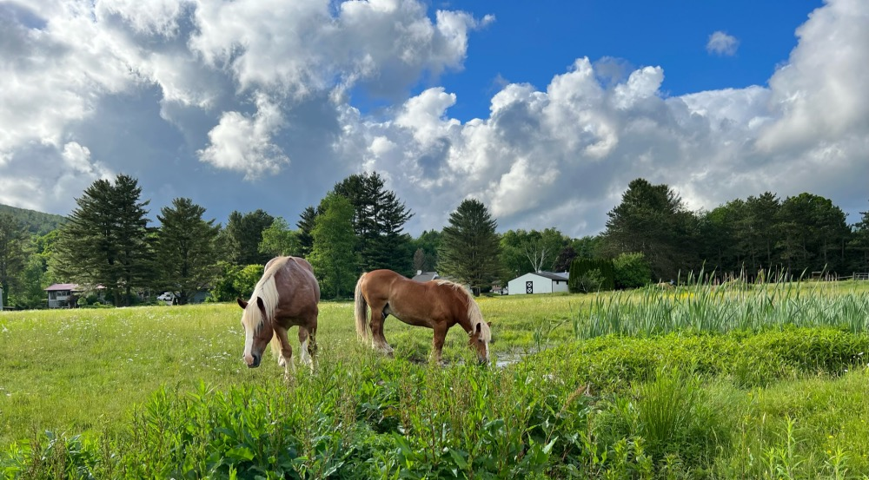

STUDENT GUIDELINES FOR ONLINE INTERACTION
We encourage open discussions but ask that you refrain from using offensive language in emails, posts, group projects, or assignments. Embracing diverse opinions enriches our learning experience, so let’s share our thoughts with care and consideration.

Netiquette
To foster clear and respectful written communications, we encourage students to embrace these netiquette guidelines:

1. Honor Your Peers: Remember that classmates and instructors are individuals deserving of kindness. Given the absence of facial expressions or tone in written communication, it’s easy for words to be misconstrued. Before hitting ‘post’, ask yourself if you would express the same sentiment face-to-face.

2. Maintain Ethical Integrity: Approach online conversations with the same honesty and respect you would in person. Always respect copyright laws and adhere to the School’s code of conduct—these principles guide us toward respectful interaction.

3. Adapt to Different Platforms: Each forum has its unique culture. Take the time to observe how others communicate in the online course and modify your style to fit the context, ensuring you connect effectively.

4. Be Considerate of Others’ Time and Resources: Keep messages concise and on topic. Use images and large files carefully and remember that not everyone can respond immediately—patience is key.

5. Maintain Professionalism in Writing: Focus on topic, take a moment to proofread, and strive for clarity and proper grammar.

6. Contribute Positively to the Learning Community: Share insights, personal experiences, and helpful resources which will enrich your discussions.

7. Embrace Positivity and Respect: Engage enthusiastically in conversations, while avoiding hostility. Keep discussions constructive and free from personal attacks.

8.Guard Privacy: Respect the confidentiality of others; never share personal information or academic work without permission.

9. Use Your Knowledge Responsibly: Rather than overpowering peers empower them. Offer assistance and encouragement to those less experienced in discussions.

10. Practice Kindness and Patience: Mistakes are a part of learning. Instead of publicly correcting someone, offer constructive feedback privately to cultivate a supportive atmosphere.

BULLYING AND CYBERBULLYING
At NESBEM, we embrace a culture of respect and positivity, which is why bullying and cyberbullying are forbidden. Bullying involves any repeated behavior—like verbal, written, or physical actions—aimed at harming someone. This includes:

- Deliberately causing emotional or physical distress.
- Instilling fear for safety or personal property.
- Creating an uncomfortable or threatening atmosphere.
- Disrespecting individuals’ rights in our community.
- Disrupting the healthy flow of our school activities.

With our strong zero-tolerance policy, we are dedicated to fostering a safe and nurturing environment for all our students.

PHOTOGRAPHY AND VIDEO RECORDING
At NESBEM, we love sharing the amazing experiences of our students and visitors, whether on campus or at our events! We may capture photographs, videos, and inspiring quotes for our marketing efforts. This gives us a great opportunity to showcase our students' journeys in promotional materials, helping to spread the word about the wonderful community we are building here.

If any student would rather not have their images or comments use, please reach out and we will provide a photo opt-out form via email.

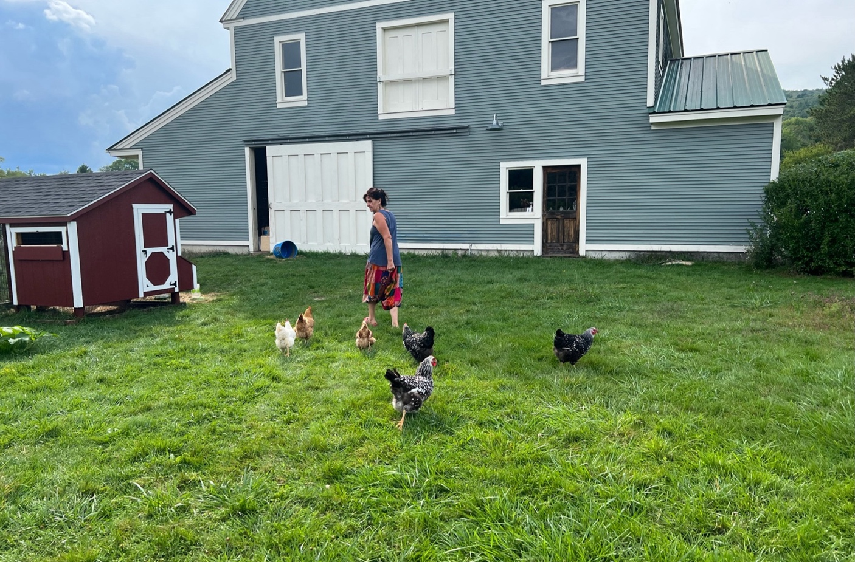

“The ultimate goal of the farmer is not the growing of crops or raising of animals,
but the cultivation and perfection of human beings.” – Masanobu Fukuoka

ACADEMIC PROGRAMS

APPLIED BIOENERGETIC MEDICINE
“The mind and body are interconnected, and by working with the body, we can access deeper levels of self-awareness.”- Alexander Lowen

Program Overview
Our Applied Bioenergetic Medicine Program offers a comprehensive and transformative 500-hour exploration into the fascinating field of bioenergetic medicine. This program is designed for those seeking advanced, science driven training in holistic health, quantum coherence, and energy mastery. This immersive journey unites the latest discoveries in quantum science and frequency medicine with intuitive development and practical applications, empowering participants to harmonize their own energy systems and positively influence surrounding energetic fields for personal, organizational, and collective wellbeing.
What distinguishes this program is its emphasis on Frequency Mastery. This method empowers practitioners to use their own energetic presence as the ultimate tool in any environment or situation. It moves beyond traditional single interventions, offering a transformative pathway to harnessing energy toward healing and personal growth.
The cohesion of frequency is coherence. It is by establishing coherence that we start to influence the web of all things, including ourselves, those around us, and the cosmos itself.

Who Is This Program For?
The Applied Bioenergetic Medicine program is for anyone who wants to deepen their understanding of holistic health, energy medicine, and the interplay between scientific knowledge and soulful practice – individually and within organizations.

This program is for Health and Wellbeing Professionals, and other practitioners eager to expand their toolkit with science-backed, soul-centered techniques. It is for those Aspiring Practitioners seeking a launch pad into energy-based medicine as well as Personal Development Seekers on a quest for self-discovery, optimal health, and personal transformation. This program is also designed for Organizational Leaders and Wellbeing Advocates who seek to improve both individual and collective health and wellbeing within the workplace.

Graduates will gain the knowledge and skills needed to pursue a variety of career paths in healthcare. These paths may include organizational leadership, consulting, education, advanced studies in graduate programs, and entrepreneurial opportunities. Our graduates will be uniquely positioned to lead innovative approaches in healthcare and make a significant impact on the future of the industry.

Program Structure
The Applied Bioenergetic Medicine Program is carefully structured in three core levels, progressing from foundational self-awareness to organizational mastery. Each level consists of focused modules blending theoretical learning with real world practices in quantum coherence, holistic health, and vibrational learning.
Upon completion you will receive a Certificate of Completion in Applied Bioenergetic Medicine, equipping you with advanced knowledge and proficiency in a diverse array of holistic healing techniques.

Program Length
Duration: 10 months
Total Hours: 500 (350 hours of applied bioenergetic medicine learning and 15- hours of applied mastery practice).

Format
- Weekly live online sessions (2 hours per week)
- Instructor led and peer supported modules
- Guided practicum and supervised experience in bioenergetic medicine

LEVEL I – SELF (Building Foundational Bioenergetic Awareness)
The initial foundation for coherent competency is the ability to navigate various stages of self-awareness and, most importantly, the ability to self-reference and respond to internal and external influences.
As we explore the pillar of Self, you will:
- Learn to identify and adjust the various layers of self—biological, psychological, narrative, spiritual, and so on
- Enhance your ability to reference, recognize, and respond to influences of frequency.

Module 1 – The Medicine of Frequency
- Introduction and Overview
- History and Application
- Foundations of Frequency
- Quantum Communication

Module 2 – Cosmic Self-Awareness – Energy, Vibration
Layers of Self – Who Am I?
- Exploring Concepts of self through a traditional and scientific lens
- Reading your own frequency
- Introduction to Cymatics
- Subtle energy exploration

Module 3 – Subtle Energy and Intention
The Sacred Art of Self-Orientation - Where am I?
- Introduction To Neuro-Linguistic Acuity – Sensory Gating
- Attuning and Adjusting
- Subtle Energy - Reiki Level 1 (or comparable practice)
- Frequency Hygiene

Module 4 – Chaos, Creativity, and R-Space
Touching the Void, Strumming the Thread
- Biofield Theory and Practice
- Resonance and Dissonance – Self
- Guided Imagery
- Liminal Perceptivity

LEVEL II – SOCIETY (Expanding Bioenergetic Influence and Vibrational Leadership)

We are all part of a Living System, and as such, we are continually influenced by “other” frequencies or vibrations. The next foundation of competency is recognizing nuance and the subtle interplay between self and other.

As we explore the pillar of Other, you will:

Learn to perceive and influence areas of entanglement

Explore scientific concepts of coupling, decoupling, and recoupling for vibrational integrity.

Module 5 – Sacred Interplay and Dynamic Tension
Attuning to “The Field” - Expanding into Influence
- Morphogenic Field Theory
- Subtle Energy Influence
- Harmonic Resonance

Module 6 – Entanglement: Coupling, Decoupling, and Recoupling
Dissonance and Resonance – Other
- Multi-Level Entanglement
- Acoustic Influence And Therapeutics
- Language And Vibration
- Local And Non-Local Influence

Module 7 – Magnetism and Chaotic Attraction
Habit Patterns and Frequency Interference
Consciousness Frequencies
Titration – Hot/cold empathy gap
Vibrational Integrity and Rapport
Working with Devices

LEVEL III – MASTERY (Alchemical Integration and Vibrational Influence)
The third foundational pillar of competency is Mastery.
Explore the interplay of dynamic tension between Self and Other.
Cultivate the ability to expand and influence your vibrational quality.

Module 8 – Weaving the Web
Gathering strands of frequency
Layering
Subtle Energy Influence – Reiki III or comparable practice)

Module 9 – Alchemical Integration

Elemental Frequency
Fire – Water – Earth – Air – Metal – Ether

Module 10 – Practice and Practicum – Demonstrate Mastery in Applied Bioenergetics

Supervision

Practice

Graduation

The New England School of Bioenergetic Medicine is a TCES Education System and Saybrook University academic partner. Completing the Applied Bioenergetic Medicine Program at NESBEM can be accepted as transfer credits into graduate studies at Saybrook University. If you are interested, please contact Dr. Stephanie Shelburne, Executive Director, for more information.

Level I | Learning Hours | Activity Hours | Total | Credit Equivalent
The Medicine of Frequency | 30 | 8 | 38
Cosmic Self Awareness | 40 | 10 | 50
Subtle Energy and Intention | 40 | 10 | 50
Chaos, Creativity, and R-Space | 40 | 10 | 50
Level I Total | 150 | 38 | 188 | 4.2
Level II | Learning Hours | Activity Hours | Total | Credit Equivalent
Sacred Interplay and Dynamic Tension | 40 | 10 | 50
Entanglement: Coupling, Decoupling, Recoupling | 40 | 10 | 50
Magnetism and Chaotic Action | 40 | 10 | 50
Level II Total | 120 | 30 | 150 | 3.3
Level III | Learning Hours | Activity Hours | Total | Credit Equivalent
Weaving the Web | 40 | 10 | 50
Alchemical Integration | 40 | 10 | 50
Practice and Practicum |  | 62 | 62
Level III Total | 80 | 82 | 162 | 3.6
Program Total | 350 | 150 | 500 | 11.11

THERAPEUTIC BIOBODY INTEGRATION
“Treating your brain, body, heart and spirit as powerful allies and practicing allowing them to be such, is an alignment of itself.

Program Overview
Discover the profound connection between mind, body, and energy in our Therapeutic BioBody Integration Program. Therapeutic BioBody Integration (TBI) is a holistic and multidimensional approach to BodyMind well-being. Grounded in the understanding that our sense of self and health are deeply connected to the body’s experiences, TBI combines a variety of therapeutic practices, including Massage, Somatic Therapy, and Energy Medicine. This integrative approach promotes overall well-being by fostering Quantum Coherence and addressing multiple dimensions of health.
TBI embraces the individual as a whole rather than as a sum of separate parts. It acknowledges the interconnected influence of emotional, mental, physical, and spiritual factors on health, striving to create harmony and balance across all aspects of life.
Our Therapeutic BioBody Integration (TBI) program offers is a comprehensive 500-hour journey into the multi-dimensional healing and integration. This program introduces a unique framework for understanding and working with the Vital Resonance System – a dynamic, layered system of physical, energetic, mental, emotional, and etheric dimensions. Drawing inspiration from Ayurvedic principles and Willima Tiller’s BioBody Suit Metaphor, the program focuses on cultivating quantum coherence within multiple resonant layers to promote balance, alignment, and healing for self and others.
Participants’ will explore how the Vital Resonance System operates as a harmonious network of energy and information, and how quantum coherence can be established and influenced to support somatic therapy. This multi-dimensional approach empowers practitioners to address imbalances and guide others toward holistic healing.

Who Is This Program For?
This program is ideal for individuals, practitioners, and educators who are passionate about exploring the profound healing potential of somatically oriented energy medicine. You will be equipped to guide your clients in incorporating somatic practices into their daily life.
​

Program Structure
The Therapeutic BioBody Integration Program is carefully structured in three core levels, progressing from foundational self-awareness to mastery. Each level consists of focused modules blending theoretical learning with real world practices in therapeutic techniques, client care, and business development, alongside somatic and energy-focused interventions.
Upon completion you will receive a transcript and Certificate of Completion in Therapeutic BioBody Integration qualifying you to sit for the National MBLEx (Massage and Bodywork Licensing Exam).
​

Program Length
Duration: 10 months
Total Hours: 500

Format
- Weekly live online sessions (2 hours per week)
- Instructor led and peer supported modules
- Guided practicum and supervised experience in bioenergetic medicine

LEVEL I – SELF AWARENESS (150 hours)
Build foundational knowledge of the Vital Resonance System and cultivate awareness of the five layers – Physical, Breath/Energy, Mental, Emotional and Etheric.

Module 1: Foundations of the Vital Resonance System
- Introduction to the five layers: Physical, Breath/Energy, Mental, Emotional, Etheric.
- The science of quantum coherence: Aligning energy and information.
- Historical influences: Ayurvedic Koshas and William Tiller’s BioBody Metaphor.
- Mapping the Vital Resonance System to physical and energetic anatomy.

Module 2: Physical Layer Awareness
- Anatomy and physiology basics: Understanding the body’s systems.
- Somatic awareness practices: Body scanning and movement exercises.
- Nutrition and the role of food in the Vital Resonance System.

Module 3: Breath/Energy Layer Exploration
- Breathwork fundamentals: Pranayama and energy flow techniques.
- Understanding the life force (prana) and its role in coherence.
- Identifying and clearing energy blockages.

Module 4: Mental and Emotional Layers
- Observing thought patterns and cognitive processes.
- Emotional awareness: Identifying and processing emotional states.
- Journaling and reflective practices for mental and emotional clarity.

Module 5: Etheric Layer Introduction
- Exploring the subtle body and its connection to the quantum field.
- Guided meditations to connect with the etheric layer.
- The role of intention and consciousness in the Vital Resonance System.

LEVEL 2: RESPONSIVENESS (200 HOURS)
Develop the ability to influence quantum coherence and respond to imbalances across the five layers using multidimensional techniques.

Module 6: Deepening Multidimensional Awareness
- Advanced techniques for harmonizing and balancing each layer.
- Interconnection of the layers: How imbalances in one layer affect the others.
- Tools for assessing coherence within the Vital Resonance System.

Module 7: Energy Dynamics and Quantum Coherence
- Working with the Breath/Energy and Etheric layers to establish flow.
- Techniques for influencing energy fields and promoting coherence.
- Understanding the role of vibrational frequencies in healing.

Module 8: Somatic Therapy Techniques
- Physical Layer: Movement, touch, and somatic release practices.
- Breath/Energy Layer: Advanced breathwork and energy alignment.
- Mental Layer: Cognitive reframing and mindfulness practices.
- Emotional Layer: Emotional regulation and somatic integration.
- Etheric Layer: Practices to connect with and influence the quantum field.

Module 9: Case Studies and Practical Application
- Analyzing real-life scenarios using the Vital Resonance System framework.
- Collaborative group work to practice techniques and provide feedback.
- Documenting and reflecting on personal and client progress.

LEVEL 3: MASTERY (150 HOURS)
Achieve mastery in aligning the Vital Resonance System and guiding others in their journey of multidimensional healing.

Module 10: Advanced Integration of the Vital Resonance System
- Synthesizing the five layers for holistic well-being.
- Exploring the etheric layer as a source of transformation and connection.
- Advanced techniques for aligning the Vital Resonance System with quantum coherence.

Module 11: Mastery of Multidimensional BioBody Intervention
- Using intention and consciousness to influence energy fields.
- Developing personalized therapeutic plans for clients.
- Advanced BioBody Intervention techniques for each layer.

Module 12: Therapeutic Leadership
- Guiding others in self-awareness, responsiveness, and coherence.
- Ethical considerations and boundaries in somatic therapy.
- Building a professional practice: Marketing, client relationships, and continued learning.

Module 13: Capstone Project
- Designing and implementing a therapeutic program for a case study.
- Presenting findings and reflections to the group.
- Peer and instructor feedback on the capstone project.

FOUNDATIONS OF LIVING WELL: ANCIENT ROOTS, MODERN RESONANCE
We need modern ideas, but we also need ancient wisdom. If we deny ancient wisdom we are making a big mistake. - Geshe Kelsang Gyatso

Program Overview
Embark on a transformative 500-hour, 10-month journey to personal mastery, thoughtfully structured into three progressive levels. Here, the timeless wisdom of the ancients flows into the leading edge of modern science, guiding you through a unique curriculum that curates a foundational understanding of your individual needs. Throughout the program, you’ll journey from foundational awareness to deeper integration and mastery, each level nurturing the next step of your self-discovery.

We honor the influence of lineage and ancestry—the threads that shape your body, mind, and soul. Drawing from ancient traditions, you’ll explore the core principles that nurture resilience and coherence across generations. Together, we shine a light on how your inherited patterns and energetic blueprints inform your present state of health.

Scientific exploration and spiritual discovery coexist in this program, guiding you through the principles of quantum coherence and harmonized vital resonant systems. Through experiential learning and reflection, you’ll sense your unique place in the web of life, awakening a deeper connection to self and source.

This program becomes your living bridge—rooted in ancient traditions, illuminated by modern knowledge, and entirely personalized to who you are. As you harmonize the wisdom of the past with the progress of the present, you’ll awaken to a life of clarity, resilience, and deep connection.

Who Is This Program For?
The Foundations of Living Well program is a deeply personal and transformative journey, entirely personalized to who you are. It is designed for those individuals wishing to journey towards a life of purpose, clarity, resilience, and deep connection.

Program Structure
The Foundations of Living Well Program is organized into three levels: Foundations of Awareness, Deep Integration, and Mastery and Embodiment.​

Program Length
Duration: 10 months
Total Hours: 500

Format
- Weekly live online sessions (2 hours per week)
- Instructor led and peer supported modules
- Guided practicum and supervised experience in bioenergetic medicine

Program Modules

Level One: Foundations of Awareness
Over the first several months, you will be guided to reconnect with the roots of wellbeing. This level illuminates the core principles of various influences of world medicine and ancestral wisdom, paired with the basics of modern nutritional science and self-care strategies. During this time, you’ll explore your personal constitution, inherent patterns, and begin to understand the interconnectedness of body, mind, and spirit. Expect deep dives into elemental theory, circadian rhythms, mindful nourishment, and daily rituals that foster resilience.

Level Two: Deep Integration
With foundational awareness established, this middle phase encourages you to weave wisdom into daily living. Building on self-knowledge, you’ll begin integrating more advanced practices such as breathwork, movement therapies, ancestral healing, and energetic balancing. This stage is designed to harmonize your inner and outer environments, leveraging tools from both ancient and modern modalities—such as quantum coherence practices and contemporary health assessments—to support deep transformation. The focus here is on applying lineage teachings and self-inquiry into practical routines that cultivate coherence and renewed vitality.

Level Three: Mastery and Embodiment
The final level is an invitation to embody the resonance you have cultivated, stepping fully into your unique rhythm and power. Here, you’ll engage with advanced practices in harmonized vital resonance, create personalized wellbeing protocols, and undertake guided reflection to recognize your evolution. This phase supports you in living as a source of inspiration, wisdom, and wellness—able to radiate your growth within your family, community, and beyond. Through mentorship, peer connection, and ongoing holistic refinement, you’ll complete the program with a sense of wholeness and aligned purpose.

NATURE-BASED THERAPEUTICS
“We are the earth, made of the same stuff; there is no other, no division between us and ‘lower or higher’ forms of being.” – Estelle Lauder

Program Overview
Our Nature Based Therapeutics Program explores the therapeutic potential of nature-based practices, focusing on vital resonance systems within self and the natural world. Participants will learn to cultivate quantum coherence by harmonizing their internal systems with the rhythms and energies of nature. This 500-hour program emphasizes "being with" nature—developing a reciprocal, resonant relationship that fosters well-being for individuals, communities, and the planet. Through practices like forest bathing, sensory immersion, and resonance-based techniques, participants will gain tools to support their own healing and guide others in connecting deeply with the natural world.

Who Is This Program For?
​ This program is perfect for individuals seeking a deeper relationship with nature, a nuanced understanding of our environmental challenges, and the tools to empower others to foster harmony with the natural world.

Program Structure
- In-Person Immersions: 200 hours (4 x 4-day immersive retreats)
- Online Learning: 150 hours (lectures, discussions, and guided practices)
- Self-Directed Practice: 100 hours (journaling, nature immersion, and personal projects)
- Capstone Project: 50 hours (design and implement a nature-based therapeutic initiative)

Program Length
Duration: 10 months
Total Hours: 500

Format
- Weekly live online sessions (2 hours per week)
- Instructor led and peer supported modules
- Guided practicum and supervised experience in bioenergetic medicine

Program Modules

Module 1: Foundations of Nature-Based Therapeutics and Vital Resonance (50 hours)
- Introduction to vital resonance systems: understanding the interplay of energy, rhythm, and coherence within self and nature
- The science of biophilia and eco-psychology
- Shifting from "being in" to "being with" nature: cultivating a reciprocal relationship
- Overview of forest bathing (Shinrin-yoku) and its role in resonance and coherence
Experiential Practices:
- Guided forest bathing sessions with a focus on resonance and attunement
- Journaling and reflective exercises on personal resonance with nature
- Group discussions on the philosophy of "being with" nature

Module 2: Quantum Coherence and Resonance Practices (75 hours)
- Understanding quantum coherence: harmonizing heart, mind, and body with natural systems
- The role of vital resonance in health and well-being
- Practices for cultivating coherence through resonance (e.g., breathwork, sound, and movement)
Experiential Practices:
- Heart-focused breathing and coherence-building exercises in natural settings
- Sound resonance practices using natural elements (e.g., water, wind, and earth)
- Meditative walks to attune to the rhythms of nature

Module 3: Therapeutic Techniques for "Being With" Nature (75 hours)
- Forest bathing as a resonance-based therapeutic modality
- Sensory immersion and deep listening as tools for attunement
- Practices for co-regulation with natural systems (e.g., trees, water, and ecosystems)
- The role of storytelling and myth in fostering resonance with nature
Experiential Practices:
- Solo and group nature immersions with a focus on resonance and reciprocity
- Sensory awareness exercises (e.g., barefoot walking, sound mapping, and tactile exploration)
- Creating personal rituals for harmonizing with natural systems

Module 4: Ecological Reciprocity and Resonant Sustainability (50 hours)
- The ethics of ecological reciprocity and resonance
- Indigenous perspectives on living in harmony with nature
- Sustainable practices that honor the vital resonance of ecosystems
Experiential Practices:
- Participatory conservation activities (e.g., tree planting, habitat restoration)
- Creating offerings or acts of gratitude for the Earth as a resonant practice
- Group discussions on sustainability and ecological responsibility

Module 5: Embodied Awareness and Resonance in Nature (75 hours)
- Somatic practices for grounding, presence, and resonance
- Mindfulness techniques for deepening connection with natural rhythms
- The role of movement and stillness in cultivating resonance with nature
Experiential Practices:
- Yoga, Qi Gong, and other movement practices in natural settings
- Silent nature retreats and solo time in the wilderness to explore resonance
- Journaling and creative expression inspired by resonant experiences in nature

Module 6: Science, Spirituality, and Resonance-Based Healing (50 hours)
- Bridging science and spirituality through resonance-based therapeutics
- The role of awe, wonder, and interconnectedness in healing
- Exploring the interconnected resonance of all life systems
Experiential Practices:
- Stargazing and cosmic awareness practices to explore universal resonance
- Guided meditations on interconnection and coherence
- Group discussions on integrating science, spirituality, and resonance

Module 7: Capstone Project and Integration (50 hours)
- Designing and implementing a nature-based therapeutic initiative with a focus on resonance and coherence
- Reflecting on personal growth and transformation through resonance practices
- Strategies for integrating resonance-based practices into daily life and professional work
Experiential Practices:
- Presenting capstone projects to the group
- Peer feedback and collaborative learning
- Closing ceremony and celebration of achievements

INTEGRATIVE HERBAL MEDICINE
“Herbs are a gift from the Earth, meant to be utilized in our journey towards wholeness.
– Alchemy of Herbs

Program Overview
Our program blends the art and science of herbal medicine, offering a rich and immersive learning experience. You’ll explore topics such as plant identification, ethical harvesting, and crafting herbal remedies while uncovering the cultural significance of botanicals. The curriculum also builds a strong foundation in essential subjects like anatomy, physiology, and herbal pharmacology, seamlessly bridging the wisdom of traditional practices with the innovations of modern science.

Who Is This Program For?
This program is designed to cater to a diverse range of participants. Whether you’re a healthcare professional looking to integrate natural remedies into your practice, a wellness coach expanding your expertise, or an individual passionate about self-care and sustainability, this program equips you with the tools and knowledge to succeed. Focusing on fostering community-driven wellness, this program empowers you to embrace and promote holistic health at every step of your journey.

Program Structure
This 500-hour program, split into ten modules, covers herbal therapeutics and provides essential knowledge of anatomy and physiology.

Module 1: Introduction to Herbal Medicine

Focus
- The history of herbal medicine across cultures.
- Understanding the cultural significance of herbal traditions.
- Ethical considerations, including sustainability and safety in herbal practices.

Herbs to Explore
- Ginger – A warming herb known for its digestive and anti-inflammatory properties.
- Chamomile – Renowned for its calming effects and digestive support.
- Elderberry – A go-to for immune system support.

Herbal Preparation and Assignments
- Learn the basics of preparing herbal teas by making an infusion or decoction.

Module 2: Creating Your Material Medica

Focus
- Introduction to energetics (e.g., warming vs. cooling, drying vs. moistening).
- Building your own materia medica by researching and documenting information on various herbs.

Herbs to Explore
- Peppermint – A cooling herb known for its digestive and energizing effects.
- Marshmallow Root – Excellent for soothing and moistening tissues.
- Calendula – A versatile herb for skin healing and lymphatic support

Module 3: Herbal Preparations

Focus
- Foundations of making herbal remedies, including infusions, decoctions, tinctures, and salves.
- Understanding extraction techniques and dosage calculations (posology).

Herbs to Explore
- Lavender – Calming properties for both mind and skin.
- Licorice Root – Balancing and harmonizing in herbal formulas.
- Rosemary – A stimulating herb to support memory and circulation.

Herbal Preparation
- Learn how to create a lavender salve to support relaxation and skin health.

Module 4: Herbs for the Skeletal System

Focus
- Supporting bone health, mineral density, and recovery from injury.
- Herbal strategies for osteoporosis and joint inflammation.

Herbs to Explore
- Nettle – Rich in minerals for skeletal health.
- Horsetail – Known for its silica content, promoting bone and connective tissue strength.
- Comfrey – Traditionally used for healing fractures and supporting tissue repair.

Herbal Preparation
- Create a nourishing bone broth infusion infused with essential herbs.

Module 5: The Nervous System

Focus
- Herbal approaches for managing stress, anxiety, sleep troubles, and cognitive health.
- Differentiating between adaptogens and nervines.

Herbs to Explore
- Ashwagandha – A potent adaptogen for managing stress.
- Lemon Balm – A nervine herb known for its calming and uplifting effects.
- Valerian Root – Commonly used for sleep support and anxiety relief.

Herbal Preparation
- Craft a sleep tonic to support relaxation and restorative rest.

Module 6: The Respiratory System

Focus
- Herbal approaches for managing stress, anxiety, sleep troubles, and cognitive health.
- Differentiating between adaptogens and nervines.

Herbs to Explore
- Ashwagandha – A potent adaptogen for managing stress.
- Lemon Balm – A nervine herb known for its calming and uplifting effects.
- Valerian Root – Commonly used for sleep support and anxiety relief.

Herbal Preparation
- Craft a sleep tonic to support relaxation and restorative rest.

Module 7: The Cardiovascular System

Focus
- Herbal approaches for managing stress, anxiety, sleep troubles, and cognitive health.
- Differentiating between adaptogens and nervines.

Herbs to Explore
- Ashwagandha – A potent adaptogen for managing stress.
- Lemon Balm – A nervine herb known for its calming and uplifting effects.
- Valerian Root – Commonly used for sleep support and anxiety relief.

Herbal Preparation
- Craft a sleep tonic to support relaxation and restorative rest.

Module 8: The Digestive System

Focus
- Herbs for digestive wellness, gut discomfort, and balancing the microbiome.
- Introducing digestive stimulants and herbs for the gut-brain connection.

Herbs to Explore
- Fennel – Known for reducing bloating and digestive discomfort.
- Slippery Elm – A soothing herb for irritated digestive tissues.
- Dandelion Root – A digestive stimulant supporting liver and bile function.

Herbal Preparation
- Prepare a unique blend of digestive bitters to stimulate digestion.

Module 9: The Reproductive System

Focus
- Herbs for digestive wellness, gut discomfort, and balancing the microbiome.
- Introducing digestive stimulants and herbs for the gut-brain connection.

Herbs to Explore
- Fennel – Known for reducing bloating and digestive discomfort.
- Slippery Elm – A soothing herb for irritated digestive tissues.
- Dandelion Root – A digestive stimulant supporting liver and bile function.

Herbal Preparation
- Prepare a unique blend of digestive bitters to stimulate digestion

Module 10: The Integumentary System

Focus
- Herbal care for skin, hair, and nails.
- Managing wounds, burns, acne, and dryness.

Herbs to Explore
- Aloe Vera – Hydrating and healing for skin and burns.
- Calendula – Renowned for wound healing and skin support.
- Gotu Kola – Promotes skin regeneration and reduces scarring.

Herbal Preparation
- Make a healing calendula-infused balm for skin care.

FOUNDATIONS OF MASSAGE THERAPY PROGRAM

“Through massage, we are reminded of the body's language and its wisdom.”

Program Overview
This program is designed to provide students with the foundational knowledge and skills required to become professional massage therapists. It meets the NCBTMB requirements for certification and prepares students for a successful career in therapeutic massage and bodywork. All 500 hours of the core curriculum are conducted live, in-class, with an instructor present.

Who Is This Program For?
This program is designed for individuals who want to pursue a career focused on helping others improve their health and well-being through therapeutic touch and body work. Graduates will be well prepared to embark on careers in a range of environments, from private practices to spas and healthcare facilities. Upon completion, graduates are eligible to sit for the NCBTMB Certification Exam.

Program Structure
This 500- hour program is design3d to be completed over approximately 6-12 months depending on the schedule of full or part-time. Classes are live, in class with an instructor present. Classes include a mix of lecture, hands-on experience, and supervised clinical hours. No online classes are allowed for non-accredited schools.

Program Breakdown
The program is divided into the following key areas, as per NCBTMB guidelines:

Anatomy, Physiology, and Kinesiology (125 Hours)
- Topics Covered:
  - Comprehensive study of the body’s systems
  - Musculoskeletal system
  - Nervous system
  - Circulatory and lymphatic systems
  - Pathology and contraindications
  - Kinesiology and biomechanics

Learning Objectives:
- Understand the structure and function of the human body.
- Identify major muscles, bones, and joints.
- Apply knowledge of body systems to massage therapy practice.

Massage Therapy Theory and Techniques (200 Hours)
- Topics Covered:
  - Swedish massage techniques
  - Deep tissue massage
  - Myofascial release
  - Trigger point therapy
  - Stretching and range of motion techniques
  - Chair massage
  - Client assessment and treatment planning

Learning Objectives:
- Demonstrate proficiency in foundational massage techniques.
- Develop treatment plans based on client needs.
- Understand the therapeutic benefits of various massage modalities.

Pathology (40 Hours)
- Topics Covered:
  - Common medical conditions and their impact on massage therapy
  - Recognizing contraindications and red flags
  - Adapting techniques for special populations

Learning Objectives:
- Identify conditions that require modifications or avoidance of massage.
- Apply critical thinking to ensure client safety.

Business and Ethics (10 Hours)
- Topics Covered:
  - Professional ethics and boundaries (minimum 6 hours)
  - Client communication and confidentiality
  - Business practices and marketing
  - Legal and regulatory requirements

Learning Objectives:
- Maintain ethical and professional standards in practice.
- Develop a business plan for a massage therapy practice.
- Understand state and national regulations for massage therapists.

Elective or Specialized Study (125 Hours)
- Topics Covered:
  - Advanced massage modalities (e.g., prenatal massage, sports massage)
  - Energy work with professional therapeutic hands-on applications
  - Use of external agents (e.g., water, heat, cold, or topicals)
  - Research literacy and applied sciences
- Self-care for therapists (e.g., yoga, active strengthening)

Learning Objectives:
- Explore advanced techniques to enhance therapeutic outcomes.
- Develop strategies for therapist self-care and longevity in the profession.
- Gain deeper insights into specialized areas of massage therapy.

The program includes CPR and First Aid certification, as required by NCBTMB.

CONTACT INFORMATION

The New England School of Bioenergetic Medicine (NESBEM)

Address: 818 Main Rd., Stamford, VT 05352

Phone: (802) 304-2824

School Email
NESBEM: info@newenglandschoolbem.org

Executive Director: Dr. Stephanie Shelburne
stephanie@liveliferesources.com

The Centre @Stone Lions Farm Director and Farm Landscape Director: Alyssa Larkin

- alyssa@liveliferesources.com

Academic Coordinator and Partner Resources: Sharon Dugan
- sharon.dugan@newenglandschoolbem.org

CATALOG - ACKNOWLEDGEMENT

The New England School of Bioenergetic Medicine (NESBEM) ensures all students can access its Catalog online. This comprehensive document serves as a guide to the school’s policies, procedures, and general information, helping students navigate every aspect of their experience at NESBEM.

I, the undersigned student, confirm that I have accessed the Catalog provided by NESBEM. I should contact the Executive Director or the Academic Coordinator for clarification if I have any questions regarding its content.

I acknowledge that the policies and information outlined in the Catalog are subject to change.

I understand that updates may be issued through official notices and that such updates may amend or replace existing policies.

I recognize that this Catalog is not a binding contract or legal agreement for admission.

Furthermore, I accept responsibility for adhering to the policies outlined in this document and any future updates or revisions.

Students are given a separate acknowledgment form to sign and submit confirming receipt of the Catalog.

The New England School of Bioenergetic Medicine
https://www.newenglandschoolbem.org/

